University of the People

CS3305 Web Programming 2

Unit 3 Written Assignment 3

Anonymous Student

**Introduction**

**Module 1-3 compelted**

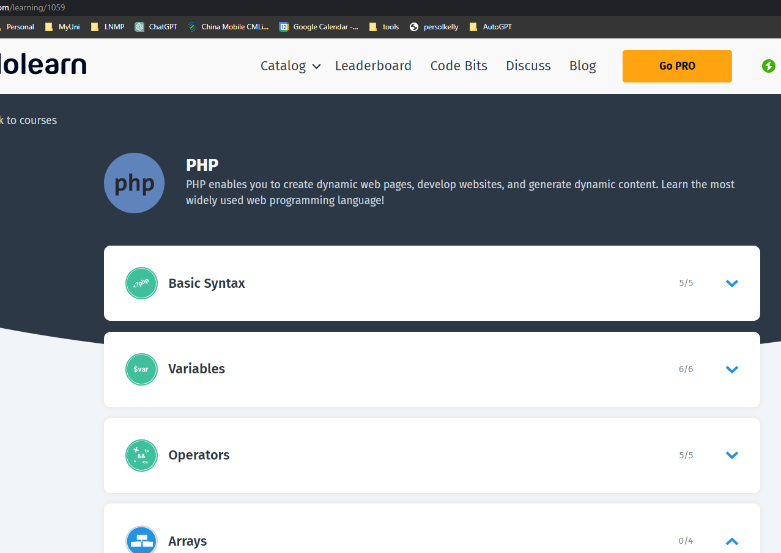

Module 1 completed 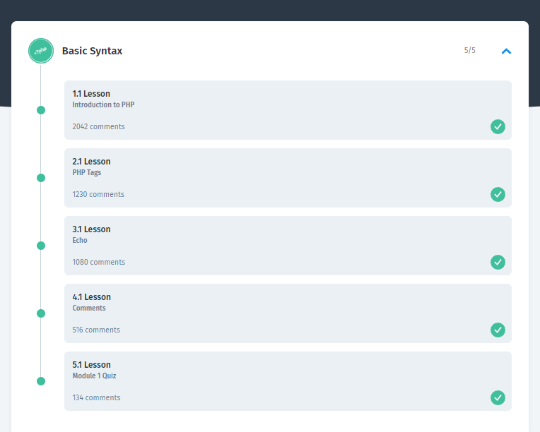

Module 2 Completed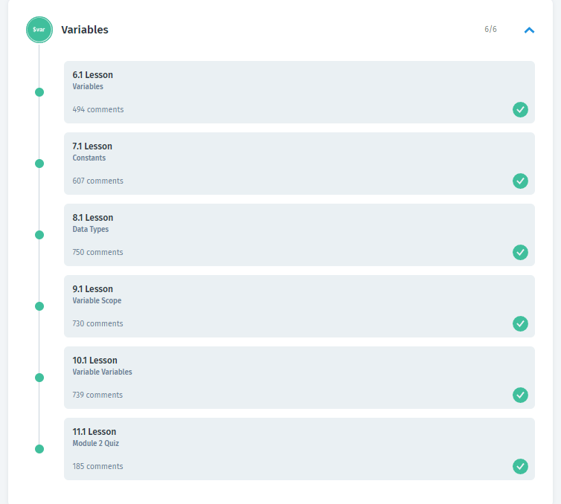

Module 3 completed